**1CWK50: MIPs Assembler:**

**Task A):**

In my program, four strings are initially stored, two are used as a prompt for the user before they enter the information and the other two are used before the information is output back to the user. The program works by initially outputting a string asking the user to input there name, then taking the input and storing it, next a string is output asking the user to enter their ID number, the ID number is then also stored, following this both are output to the screen for the user to see.

Screenshots:

First input:

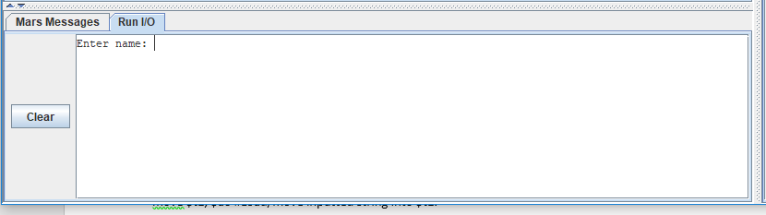

Second input:

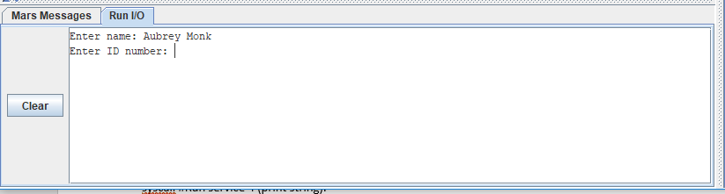

Final outputs:

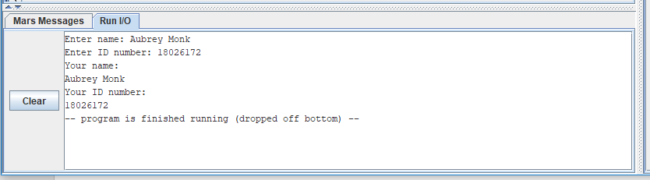

Full code (Screenshot):

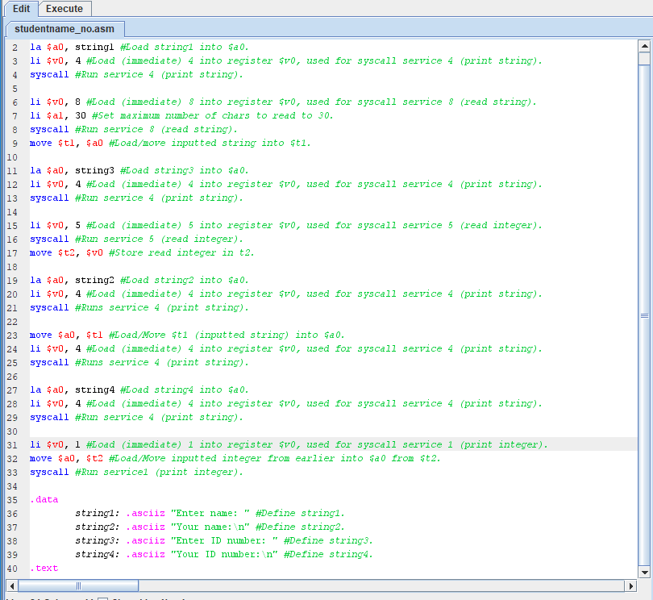

Code:

la $a0, string1 #Load string1 into $a0.

li $v0, 4 #Load (immediate) 4 into register $v0, used for syscall service 4 (print string).

syscall #Run service 4 (print string).

li $v0, 8 #Load (immediate) 8 into register $v0, used for syscall service 8 (read string).

li $a1, 30 #Set maximum number of chars to read to 30.

syscall #Run service 8 (read string).

move $t1, $a0 #Load/move inputted string into $t1.

la $a0, string3 #Load string3 into $a0.

li $v0, 4 #Load (immediate) 4 into register $v0, used for syscall service 4 (print string).

syscall #Run service 4 (print string).

li $v0, 5 #Load (immediate) 5 into register $v0, used for syscall service 5 (read integer).

syscall #Run service 5 (read integer).

move $t2, $v0 #Store read integer in t2.

la $a0, string2 #Load string2 into $a0.

li $v0, 4 #Load (immediate) 4 into register $v0, used for syscall service 4 (print string).

syscall #Runs service 4 (print string).

move $a0, $t1 #Load/Move $t1 (inputted string) into $a0.

li $v0, 4 #Load (immediate) 4 into register $v0, used for syscall service 4 (print string).

syscall #Runs service 4 (print string).

la $a0, string4 #Load string4 into $a0.

li $v0, 4 #Load (immediate) 4 into register $v0, used for syscall service 4 (print string).

syscall #Run service 4 (print string).

li $v0, 1 #Load (immediate) 1 into register $v0, used for syscall service 1 (print integer).

move $a0, $t2 #Load/Move inputted integer from earlier into $a0 from $t2.

syscall #Run service1 (print integer).

.data

string1: .asciiz "Enter name: " #Define string1.

string2: .asciiz "Your name:\n" #Define string2.

string3: .asciiz "Enter ID number: " #Define string3.

string4: .asciiz "Your ID number:\n" #Define string4.

.text

**Task B:**

My program outputs a string asking the user to input the last two digits of their ID number, once done the input is stored in register ‘$t1’, and then a value of two is loaded into a register ‘$t0’. The users input (in ‘$t1’) is divided by 2 (stored in ‘$t0’), the quotient of this division is automatically stored in the ‘lo’ register, the contents of the ‘lo’ register are moved to the ‘$t2’ register and then the contents of the ‘$t2’ register are outputted to the screen for the user to see.

Input:

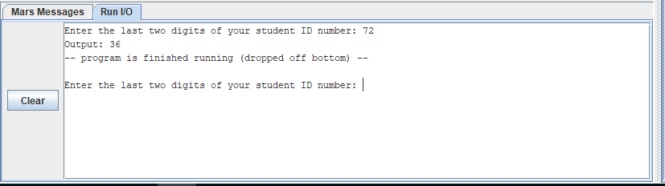

Output:

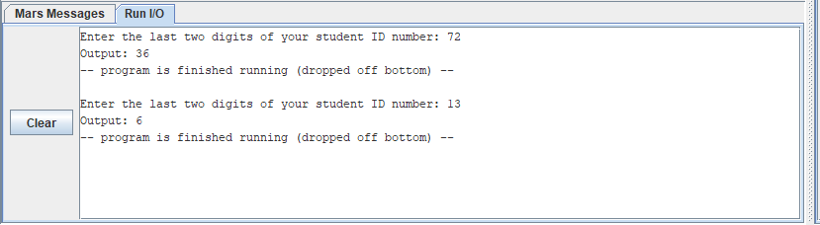

Screenshot of code:

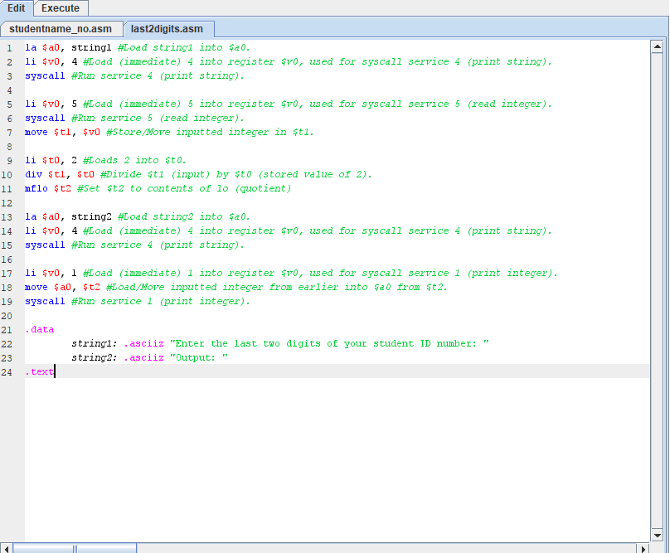

Code:

la $a0, string1 #Load string1 into $a0.

li $v0, 4 #Load (immediate) 4 into register $v0, used for syscall service 4 (print string).

syscall #Run service 4 (print string).

li $v0, 5 #Load (immediate) 5 into register $v0, used for syscall service 5 (read integer).

syscall #Run service 5 (read integer).

move $t1, $v0 #Store/Move inputted integer in $t1.

li $t0, 2 #Loads 2 into $t0.

div $t1, $t0 #Divide $t1 (input) by $t0 (stored value of 2).

mflo $t2 #Set $t2 to contents of lo (quotient)

la $a0, string2 #Load string2 into $a0.

li $v0, 4 #Load (immediate) 4 into register $v0, used for syscall service 4 (print string).

syscall #Run service 4 (print string).

li $v0, 1 #Load (immediate) 1 into register $v0, used for syscall service 1 (print integer).

move $a0, $t2 #Load/Move inputted integer from earlier into $a0 from $t2.

syscall #Run service 1 (print integer).

.data

string1: .asciiz "Enter the last two digits of your student ID number: "

string2: .asciiz "Output: "

.text